LV3 Airframe Module Layup Instructions

## Tips and Tricks

1. Staying clean and organized is very important.
2. A heat gun is super useful for dealing with the adhesive film. However, be careful not to let it get too hot. A little bit goes a long way.
3. Adhesive film is hard to remove from its backing, especially with gloves on. You can use the tongue depressor against the edge after sticking it to the part to get the backing off. Leave the blue side of the adhesive on.
4. The carbon sticks to the adhesive film too well, don’t stick it down unless you are sure it is in the correct spot.

## Procedure

1. Clean all surfaces and the floor using acetone, brooms etc.
2. Put on gloves
3. Arrange 4 work surfaces, each with a specific task:
   1. Layup
   2. Tool treatment
   3. Cutting pieces of composite material
   4. Aluminum mating ring treatment
4. Clean all the metal tools and part surfaces using acetone. Each part should cleaned thoroughly so that it leaves no visible residue on the towel.

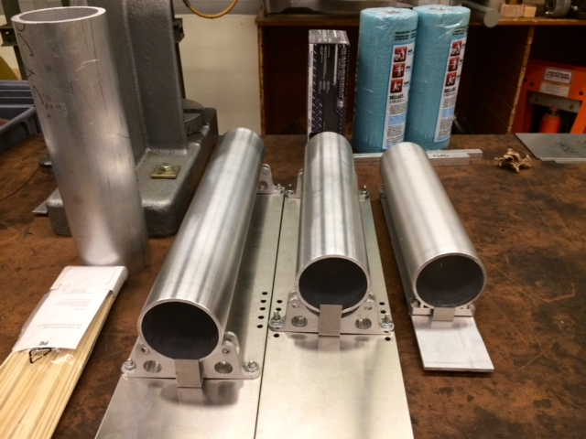

1. Wax the mandrels using Orca hybrid mold release according to the instructions on the can.
2. Similarly, wax the inside of the aluminum mating rings, making sure not to get any mold release on the carbon bond surfaces of the aluminum rings
3. Thoroughly sand the carbon bond surfaces of each aluminum mating ring to remove the oxide layer. When you’re finished sanding, the surfaces must be cleaned thoroughly with acetone.
4. Apply the 3M anti-galvanic corrosion agent to the bond surfaces by following the instructions on the package. In general, the solution should be applied with a brush constantly for about 3 minutes then left to dry and set for at least an hour.

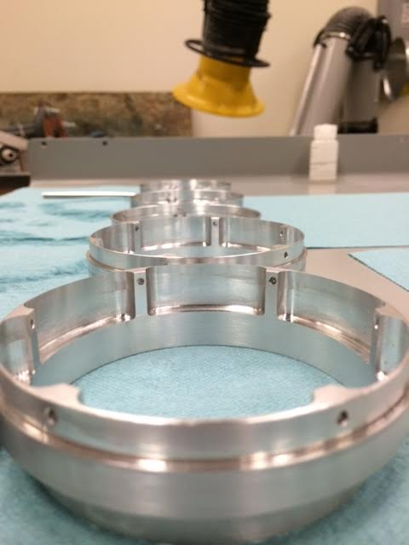

1. Cut the following layers using a sharp razor (except the core) and the cutout templates. Templates are labeled as steps 1-6.

**Step 1**: Cut 2 strips of aluminum step adhesive

**Step 2**: Cut 1 carbon inside ply

**Step 3**: Cut 1 inside film adhesive layer

**Step 4**: Mark with sharpie the outline of the honeycomb core layer. Use scissors to cut the core

**Step 5:** Cut 1 outside film adhesive layer

**Step 6:** Cut 1 carbon outside ply

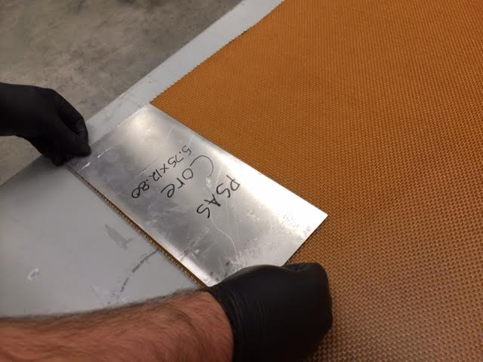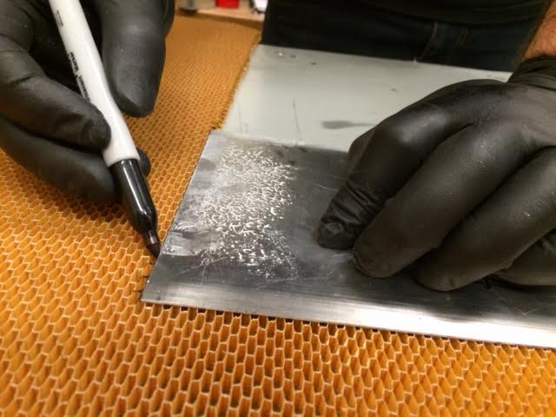

1. Lay everything out. ***If you need more than ~30minutes of time before laying up the module, the carbon and adhesive layers must be put back in the freezer until layup****.*

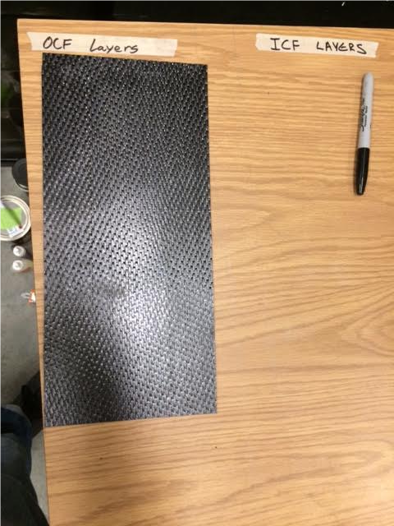

1. Slide the aluminum mating rings over the mandrel, making sure the orientation is correct
2. Slide the dummy layup rings onto the mandrel and fasten them to the mating rings
3. Fasten the dummy rings to the mandrel

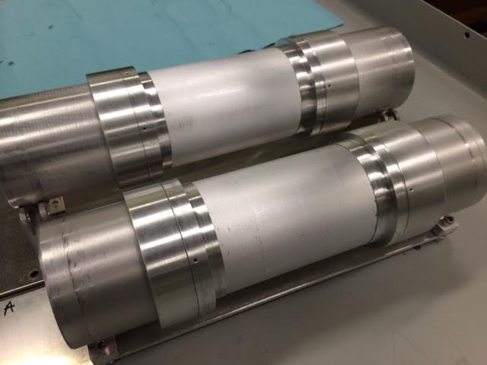

1. Wrap the two thin strips of adhesive around the lower bond surface of the mating rings.
2. Wrap the first layer of carbon. Make sure that the adhesive film layer underneath doesn’t move off of the step and onto the mandrel. It works best if one person does the aligning and the other rotates the mandrel. Wrap it snugly, but be sure to not introduce any warping of the fibers. Don't allow any air bubbles to remain.

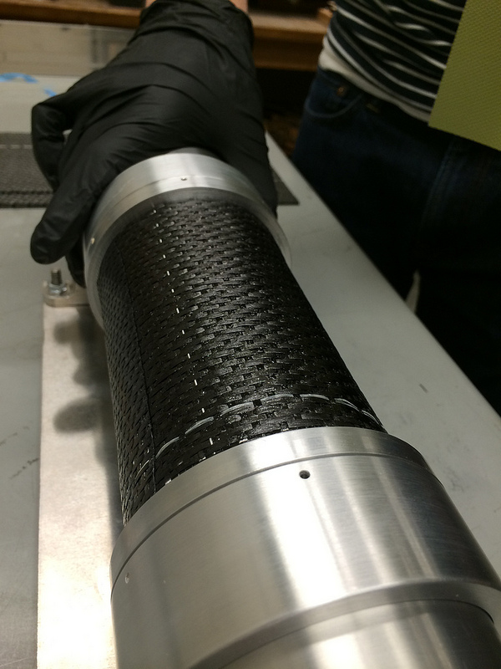

1. Use a tongue depressor in a rocking fashion (perpendicular to mandrel axis) to flatten out the carbon on top of the bond areas. This ensures good contact between the carbon and the bond area.

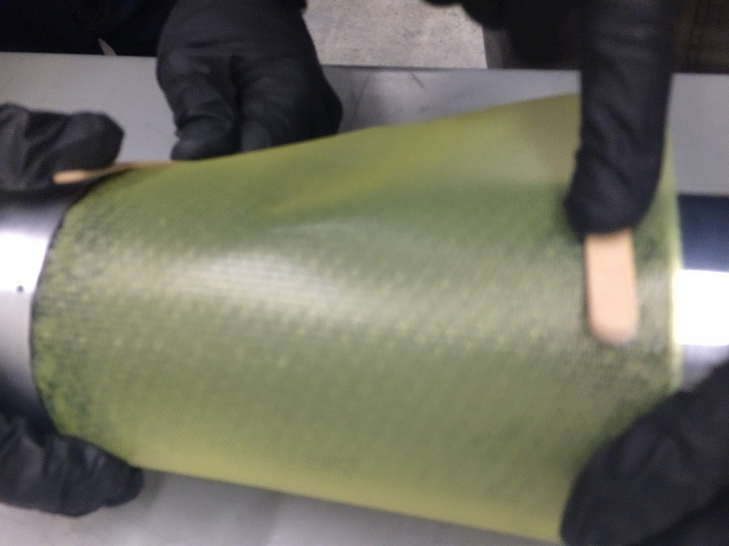

1. Wrap the inside layer of film adhesive on top of the carbon. Try to align the edges as well as possible, but it’s okay if there are wrinkles. The adhesive will melt and flow during cure.

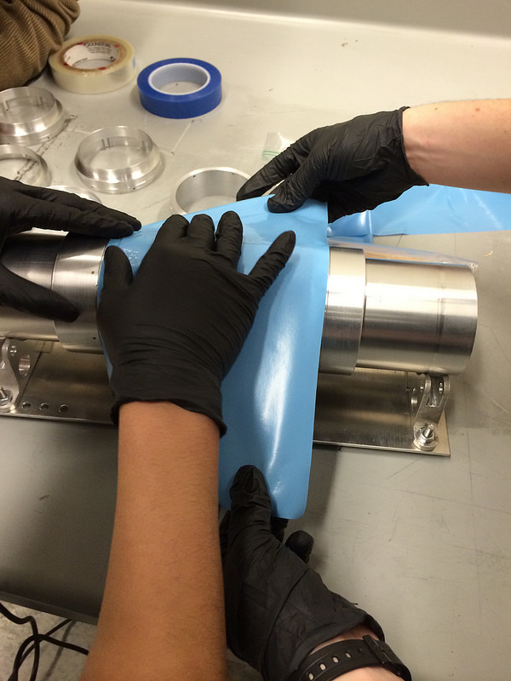

1. Wrap the honeycomb core layer. Use the heat gun sparingly to warm the adhesive underneath and press the core onto the adhesive to make it stick.
2. When you get to the end of the core wrap, compress the excess length of core and force it up against the other side. This compressed area will prevent gaps from forming at the core seam during cure.

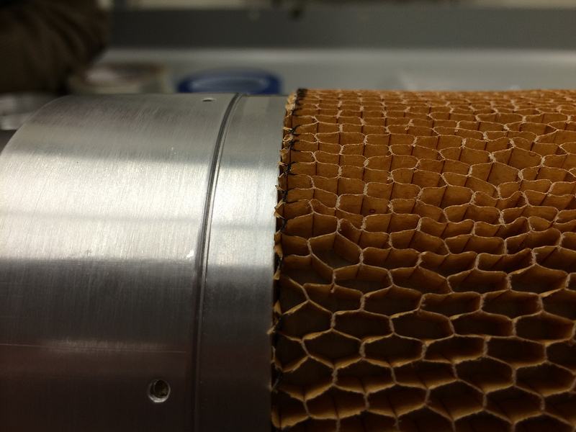

1. Wrap the outside layer of adhesive film. This one will go over both the core and rings. Try to align the edges of the adhesive with the step on the mating ring as well as possible.
2. Wrap the outside layer of carbon. Make sure that the lettering on the carbon does not end up on the outside of the module.

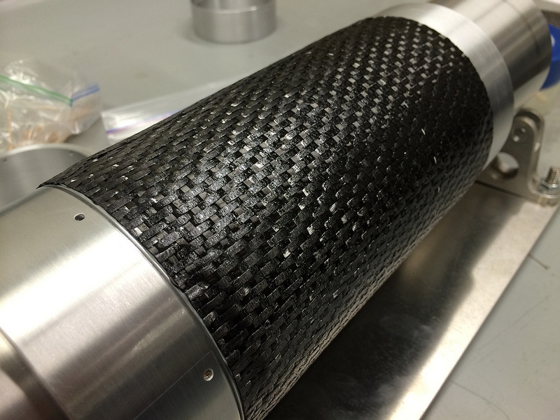

1. Wrap the perforated shrink tape across the length of the mandrel so that it overlaps itself 50% each time. Start the wrap on the dummy, taping it down well with the flash tape (clear blue). Then, have one person rotate the mandrel, one person hold the shrink tape roll, and one person align the tape as it is wrapped. The person aligning the shrink tape should also tension the tape so that it is taught as it is wrapped but not tight. End the shrink tape at the other dummy and secure it with flash tape.

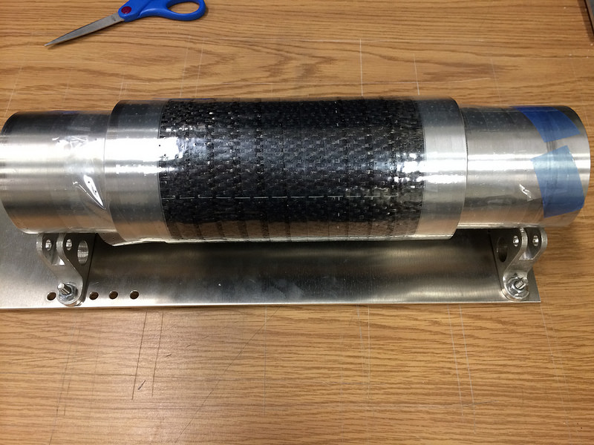

1. Wrap a diaper made from the breather cloth and use flash tape to secure it.

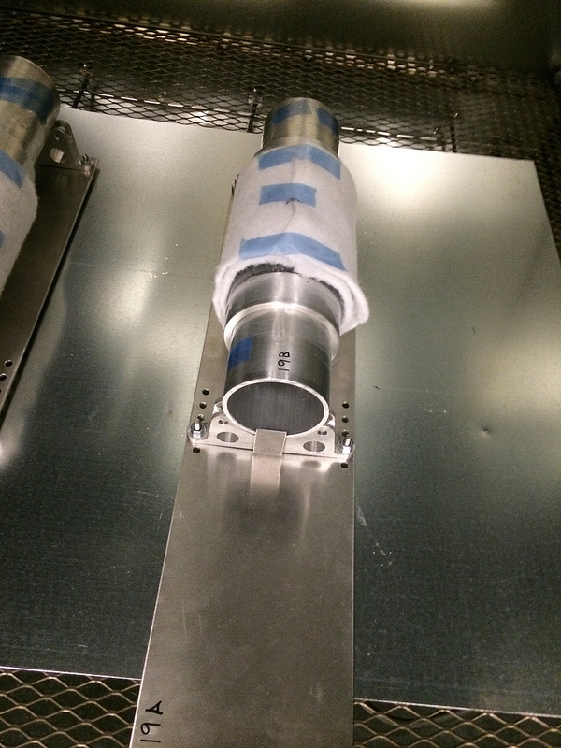

1. Put The mandrel into the oven on the aluminum stands
2. Turn on bake cycle. 3deg/min ramp up to 350F, where it is held for 2 hours.
3. Let cool slowly. The part will crackle as it cools down. This is normal.
4. Sometimes you have to hammer the parts off the mandrel. Whatever method you use, be sure not to damage the aluminum rings

